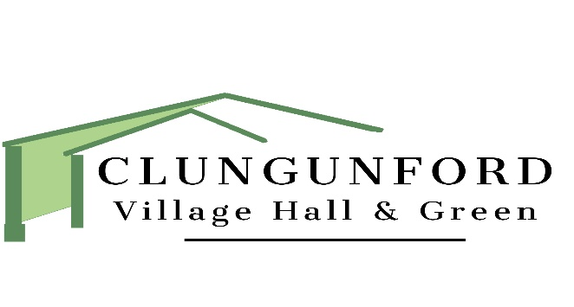

**Clungunford Village Hall and Green**

**Environmental Policy**

The Trustees of Clungunford Village Hall recognise that our activities, and those of our users, impact upon the environment. Consequently, we embrace the principle of considering the environmental impact of the activities undertaken by the hall management and users. We undertake to comply with the relevant laws and seek to promote environmental improvement and pollution prevention practices in all our activities and relationships with users, suppliers and visitors.

**POLICY STATEMENT**

Clungunford Village Hall and Green Management Committee aims to carry out its activities with

environmental efficiency, actively seeking to protect and enhance the local environment within its remit whilst endeavouring to ensure wider adverse environmental impact does not occur as a result.

**AIMS**

In all its activities the Village Hall Management Committee will aim to:

* Use energy, natural resources and non-renewable resources efficiently and strive to minimise

waste, pollution & cost.

* Inform hall users of the Committee’s environmental activities and encourage response and feedback.
* Encourage & support individual behaviour change in users, leading by example and

supporting environmentally friendly activities.

**PRINCIPLES**

Clungunford Village Hall Management Committee will strive to:

* Meet all relevant environmental legislation and regulations
* Regularly update and improve standards in light of increased understanding and knowledge
* Avoid the creation of unnecessary waste by adhering to a policy of considered, strategic

purchasing

* Recycle and reuse waste materials where possible
* Dispose of all necessary waste through safe and responsible methods
* Encourage the responsible use of energy and water
* Respect and protect natural resources by practising conservation and good management in particular relation to the Village Green
* Encourage contractors and suppliers to minimise their impact on the environment
* Encourage its users, volunteers and sub-contractors take responsibility for ensuring that the best environmental policy is used and adhered to at all times

**SPECIFIC ACTIONS**

**Energy Conservation**

The Committee will monitor its energy use and improve upon energy efficiency within its buildings by adopting energy-saving measures and equipment. The Committee will increase awareness of energy efficiency and encourage energy-conserving behaviour amongst Hall users and contractors.

**Water**

Water will be used efficiently for Committee activities and on Committee premises. Particular attention will be required for the croquet green in the summer months.

**Waste**

The Committee will minimise its waste production wherever possible, by reducing, repairing and reusing resources, and by recycling the waste its activities produce, where facilities exist. Rubbish will be disposed of safely, following the correct procedures, and only licensed contractors will be used to deal with hazardous wastes. The Committee fully endorses the policy of Reduce, Reuse, Recycle.

**Transport**

The Committee will continue to encourage sustainable transport systems within the Village, such as

Cycling, walking and car sharing.

**Biodiversity and Green Spaces**

The Committee will, wherever possible, consider the conservation and promotion of local biodiversity in all its activities, but particularly with regard to the management of the Village Green.

**Products**

The committee will regularly review the cleaning products used within the hall to promote the use of environmentally friendly products wherever possible while weighing up the cost versus benefit.

**Reducing Carbon Footprint**

When buying stock for The Gunnas Bar or food for events, initial consideration should always be given to locally sourcing products and supporting local businesses. Again, the cost versus benefit will be a consideration.

Policy Date: March 2023

Policy Review Date. April 2026

Author: Elizabeth Lyster