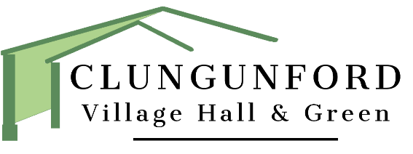

**Clungunford Village Hall & Green**

**Alcohol sales and ‘Challenge 25’ policy**

Clungunford Village hall shall ensure that any sales of alcohol on its premises comply with legal requirements and the conditions of our Premises Licence.

The hall will:

• not allow anyone under 18 to buy alcohol.

• not sell to anyone who is drunk.

• not sell alcohol outside of the hours stipulated in the Hall Premises Licence.

• operate the ‘Challenge 25’ policy and apply the following principles: -

* **Be Cautious** – it is very hard to tell a young person’s age, so ensure that we check even those that look older than 18. If they look 25 or under then check for proof. This is ‘Challenge 25’
* **Be Consistent** – always check ID if the person looks 25 or younger. Remind them that other staff members will also want to see ID and so not to expect to be served without it next time.
* **Be Clear** – use signage to inform people that they will be checked.
* **Be Courteous** – if we have to refuse a sale, we will explain that we are complying with the Law and advise the young person that they can obtain a proof of age card.
* **Be Careful** – there is evidence that bar staff can fail to challenge underage purchasers if they feel afraid of the consequences. Remember that the CCTV is there for bar staff protection - and point this out if necessary. Bar staff will not take any action that puts them in danger.

Remember - IT IS AN OFFENCE TO PURCHASE OR ATTEMPT TO PURCHASE ALCOHOL IF YOU ARE UNDER THE AGE OF 18 (section 147 Licensing Act 2003)

The Hall Management Committee will ensure that it meets the conditions to serve alcohol contained in its Premises License. In particular:

* Children under the age of 18 shall only be allowed in the bar if accompanied by an adult.
* Cigarettes are not to be sold on the premises.
* CCTV shall operate at the bar and entrance.
* Customers shall be asked to leave the premises quietly.
* No glasses shall be allowed outside.
* A ‘Challenge 25’ policy shall operate.

**Challenge 25 and Proof of Age Cards**

There are a number of legitimate sources of ID that young people can get to prove their age.

However ONLY ACCEPT CREDIBLE PHOTO PROOF OF AGE – this includes:

* A Proof of age card schemes carrying a PASS logo. The PASS scheme, which is a voluntary industry initiative supported by the retail and hospitality industries, is endorsed by the UK
* Government.
* A Passport
* A Photo driving licence
* Military ID

**Remember - IF HALL BAR VOLUNTEERS ARE IN ANY DOUBT, THEY ARE PERFECTLY WITHIN THEIR RIGHTS TO REFUSE A SALE EVEN IF SOMEONE HAS SHOWN ID**

**Recording incidents**

The Premises Licence for the hall requires that a challenge made to someone who looks 25 or younger must be recorded. The ‘Alcohol Sales Refusal Incident Book’ is held behind the bar.

This should include ALL incidents when a customer is refused a sale of alcohol, including where no ID is available.

The information to record should be:

* date & time (important for finding CCTV imagery if necessary)
* name of volunteer bar staff making the challenge
* reason for refusal
* name of the customer - if available
* any other useful information

Reviewed March 2023.

Next review 2026